Walkthrough 8 I18N

https://sapui5.hana.ondemand.com/#/topic/70ef981d350a495b940640801701c409

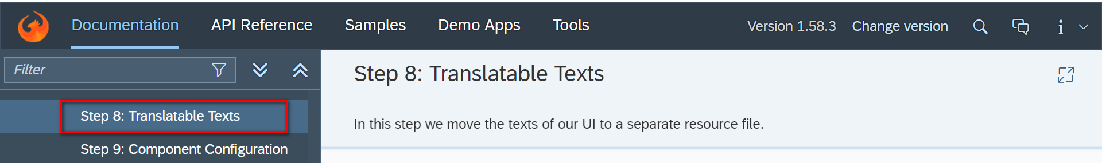

Core Codes:

I18n

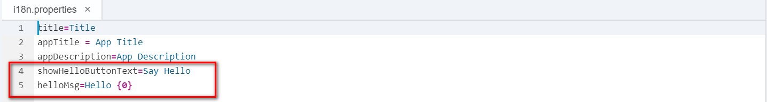

Controller.

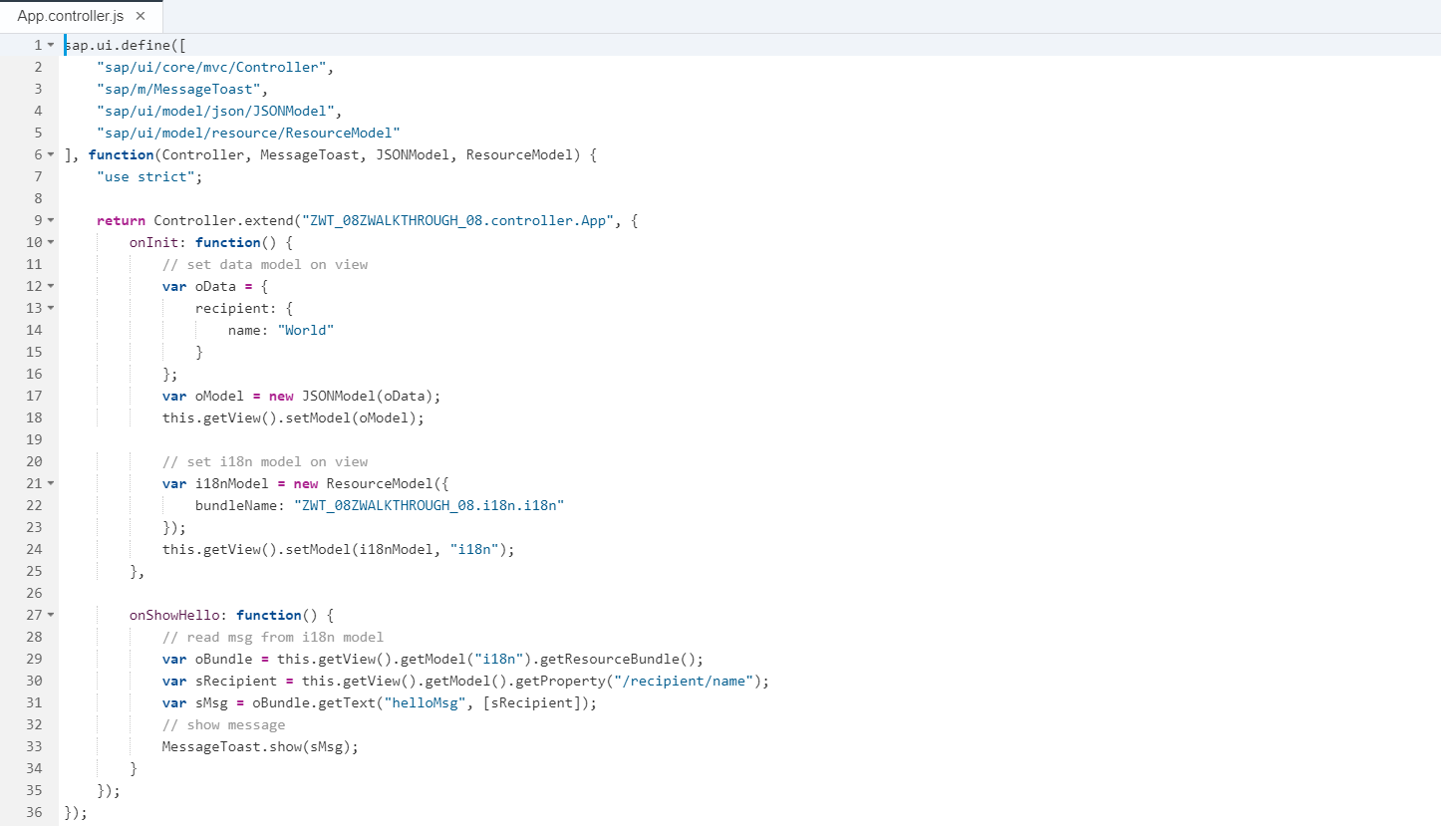

View.

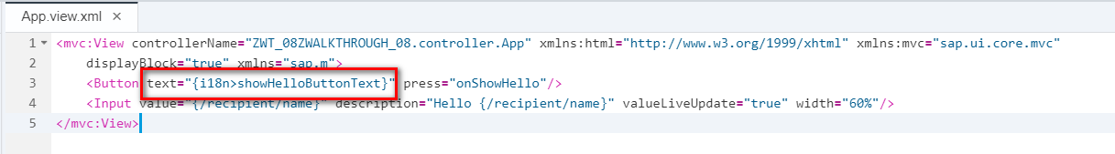

Result:

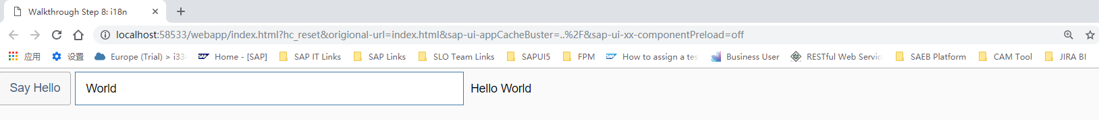

Git:

2018/11/02 XiaoMi Beijing Zac,Xie